2023-2024
Guide to Graduate PLUS Loans

INSIDE:
Program Description 2 PLUS Loan Eligibility
Credit Requirements
Interest Rates
Loan Fees
- Repayment
- Annual Loan Limits
Applying for a Loan
Loan Disbursements 4 Helpful Contacts

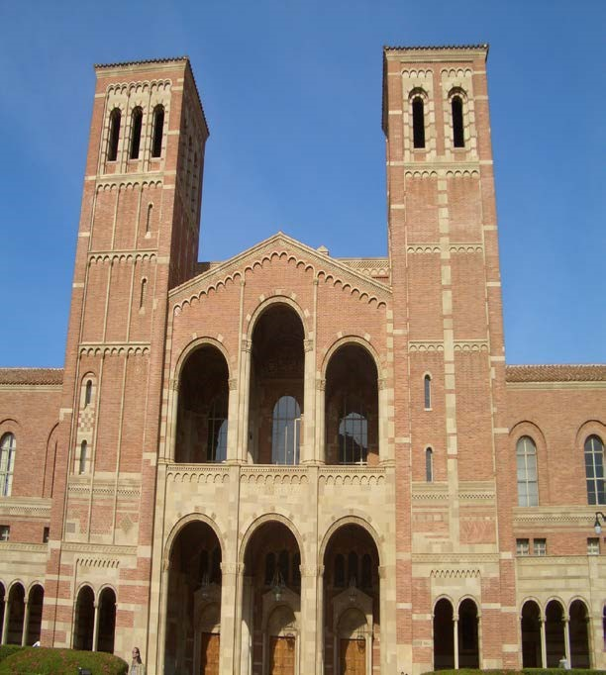
David Geffen School of Medicine at UCLA Financial Aid and Scholarships
2011
2012
PELL GRANT GUIDE

885 Tiverton Drive, Geffen Hall Suite 305

Los Angeles, CA 90095-7020
dgsomfas@mednet.ucla.edu

Guide to Graduate PLUS Loans Page 2
Page 2

Program Description
Graduate PLUS Loans are a part of the William D. Ford Federal Direct Loan Program. These loans are available to graduate students who have borrowed the maximum from Direct Unsubsidized loans. Students may borrow up to their full cost of education for the academic year less any other aid received for that year. The borrower (you) and the DGSOM Financial Aid Office work with the Department of Education (DOE) to complete the loan process and deliver loan funds to you. Your Financial Aid Notification (FAN) will let you know the amount of Direct Graduate PLUS Loan that you are eligible to borrow.

PLUS Loan Eligibility
- You must complete the Free Application for Federal Student Aid (FAFSA) each academic year.
- You must be a US citizen or an eligible non-citizen.
- You must be enrolled at least half-time in an accredited program.
- A credit check will be required before DOE will approve your eligibility.
- If your credit is denied you may still be able to qualify for PLUS by appealing the credit decision or applying with an endorser.

Credit Requirements
A PLUS loan applicant is considered to have an adverse credit history if he or she:
- Is 90 or more days delinquent on any debt as of the date of the credit report, or
- Has been the subject of a default determination, bankruptcy discharge, foreclosure, repossession, tax lien, wage garnishment or write-off of debt under Title IV of Higher Education Act during the 5 years preceding the date of the credit report.
- If you are unable to qualify for PLUS based on your credit, the federal loan processor will provide you with information on how to submit an appeal or apply with an endorser.

If you are concerned about credit and your ability to qualify for a Graduate PLUS Loan you can apply for the loan at www.studentaid.gov to see if you will qualify.

Interest Rates
Grad PLUS loans accrue interest at the time of disbursement.

For loans disbursed on or after 7/1/22: 7.54% fixed interest

Beginning 3/20/20 and extended through 6/30/23: Temporary 0% Interest as a Result of the COVID-19 National Emergency. To provide relief to student loan borrowers during the COVID-19 national emergency, interest on most federal student loans, beginning on March 20, 2020, has been temporarily set at 0%.

Guide to Graduate PLUS Loans | Page 3

Loan Fees
Most federal student loans have loan fees that are a percentage of the total loan amount. The loan fee is deducted proportionately from each loan disbursement you receive while enrolled in school. This means the money you receive will be less than the amount you actually borrow. You’re responsible for repaying the entire amount you borrowed and not just the amount you received.

For loans disbursed between 10/01/20 – 10/1/23: 4.228% origination fee will be charged by DOE.

For loans disbursed on or after 10/01/23: origination fee TBD.

Repayment
Graduate PLUS Loans are automatically deferred until 6 months after graduation or after enrollment drops below half time. The interest on the loan starts accruing at disbursement and the borrower has an option to make interest only payments while enrolled.

Standard repayment period is 10 years but can be extended. Please go to www.studentaid.gov for information about different repayment plan options, deferments and forbearances available through the Department of Education.

Deferments and forbearances are available for federal loans to eligible borrowers who need to delay the repayment of their loan. Go to www.studentaid.gov for additional information.

Annual Loan Limits
Graduate PLUS can be borrowed to cover the graduate student’s annual cost of education (based on the financial aid budget) less any other loans or graduate support or other assistance received for the year.

Applying for a loan
Eligibility for federal loans is based on the information you submit on your Free Application for Federal Student Aid (FAFSA) each year. Your eligibility will be communicated via a Financial Aid Notification (FAN).

Accept the loan on your FAN – If you would like to borrow less than the loan amount offered, indicate the amount you want to borrow in the space provided on the eFAN. If you do not need all of the loans offered on your FAN, borrow the maximum Unsubsidized Direct Loan you are eligible for before accepting a Graduate PLUS Loan.

Complete a Master Promissory Note (MPN), if you are a first-time borrower – You must complete an MPN the first time you borrow a Graduate PLUS Loan. Once completed the Direct Loan MPN is valid for 10 years so continuing borrowers do not have to complete one each year.

Guide to Graduate PLUS Loans Page 4

Complete a Debt Management Session (DMS), Page 4 if you are a first-time borrower at UCLA – If you are borrowing a Graduate PLUS Loan for the first time at UCLA you are required to complete a Graduate PLUS Debt Management Session with the Student Loan Office. Go to www.loans.ucla.edu to complete your Grad PLUS DMS on line. If you have any questions about this requirement, please contact the Student Loan Office at 310-825-9864.

Loan Disbursements
The total loan amount you accept on your FAN will be divided equally among the terms, for which you have been awarded. If you want to accept a portion of your loan for different terms of enrollment than those reflected on your FAN, please notify the DGSOM Financial Aid & Scholarships Office. Your loan will be disbursed to your BruinBill account at the beginning of each term. Any funds remaining after your BruinBill balance is paid will be refunded to you.

You have the right to request a cancellation or a reduction of your loan provided that you submit a written request to the Financial Aid Office within 120 days of the disbursement date

We recommend that you sign up for BruinDirect on your BruinBill account online so that your refund can be deposited directly to your bank account via electronic fund transfer (EFT). If you do not have Bruin Direct, a refund check will be mailed to you by Student Accounting. Paper checks are processed only once a week, on Thursdays.

Students pay tuition and fees for, and enroll in, a full-time course load each semester. However, to be eligible for Direct Loans, students must be enrolled at least half time at the time of disbursement. The definition of half-time status for medical school is enrollment in at least 12 weeks of coursework per semester.

If you take a leave of absence or withdraw from school, depending on the effective separation date, you may be billed for all or part of the loan(s) disbursed to you for that term.

In order for funds to be disbursed, federal loans must be originated by the school before the last day of the enrollment period. If you are accepting a Direct Loan, please submit your FAN no less than 5 business days before the end of the term in which you are enrolled.

Guide to Graduate PLUS Loans | Page 5

Helpful Contacts

Federal Student Aid Processor – to find more information about Direct Loans, complete your Direct Loan Master Promissory Note, or find information about Direct Loan repayment plans and managing your loan repayment go to www.StudentAid.gov

DGSOM Financial Aid & Scholarships Office – to find more information about your loan eligibility, the status of your application and disbursements, e-mail us at dgsomfas@mednet.ucla.edu.

DGSOM Registrar – with questions regarding what constitutes at least half-time status for financial aid eligibility: registrar@mednet.ucla.edu or call (310) 206-0434

UCLA Student Loan Office – to find more information about UCLA Debt Management Session requirement or to complete DMS on-line, go to www.loans.ucla.edu or call 310-825-9864.

UCLA Student Accounting – to sign up for Bruin Direct (electronic deposit of your financial aid refund to your bank account) or to check on the status of your refund, go to: https://www.finance.ucla.edu/ or call 310-825-9194.

