2023-2024
Guide to Unsubsidized Loans

INSIDE:
2 Program Description
2 Loan Eligibility
2 Interest Rates
2 Loan Fees
- Repayment
- Annual Loan Limits
Applying for a Loan
4 Disbursements
Helpful Contacts

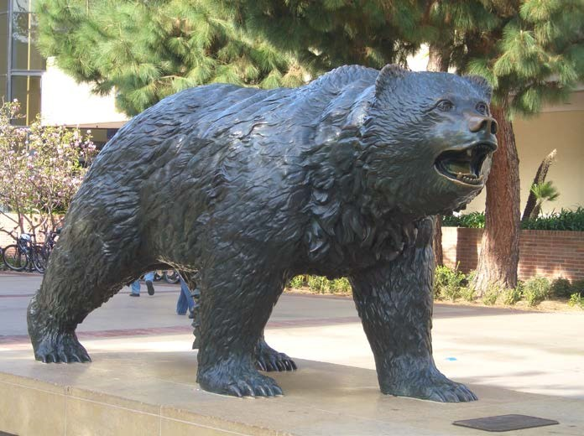

David Geffen School of Medicine at UCLA2011 2012 PELL GRANT GUIDE
Financial Aid and Scholarships Office
885 Tiverton Drive, Geffen Hall Suite 305

Los Angeles, CA 90095
dgsomfas@mednet.ucla.edu

Guide to Unsubsidized Loans Page 2

Program Description _{Page 2}
Unsubsidized Loans are a part of the William D. Ford Federal Direct Loan Program. Graduate/Professional students are eligible to apply. The borrower (you) and the DGSOM Financial Aid & Scholarship Office (FAS) work with the Department of Education (DOE) to complete the loan process and deliver loan funds to you. Your Financial Aid Notification (FAN) will let you know the amount of Direct Loan that you are eligible to borrow.

Unsubsidized Loan Eligibility
- You must complete the Free Application for Federal Student Aid (FAFSA) each academic year.
- You must be a US citizen or an eligible non-citizen.
- You must be enrolled at least half-time in an accredited program.
- Eligibility for Unsubsidized Loans is not need-based.

Interest Rates
Unsubsidized loans accrue interest at the time of disbursement.

For loans disbursed on or after 07/01/22: 6.54% fixed interest rate

Beginning 3/20/20 and extended through 6/30/23: Temporary 0% Interest as a Result of the COVID-19 National Emergency. To provide relief to student loan borrowers during the COVID-19 national emergency, interest on most federal student loans, beginning on March 20, 2020, has been temporarily set at 0%.
2011-2012 PELL GRANT GUIDE

Loan Fees
Most federal student loans have loan fees that are a percentage of the total loan amount. The loan fee is deducted proportionately from each loan disbursement you receive while enrolled in school. This means the money you receive will be less than the amount you actually borrow. You’re responsible for repaying the entire amount you borrowed and not just the amount you received.

For loans disbursed between 10/01/20 – 10/01/23: 1.057% origination fee will be charged by DOE.
For loans disbursed on or after 10/01/22: origination fee TBD

Repayment
Loans do not enter repayment for six months after a student graduates or drops below half-time (grace period). Principal and interest on Unsubsidized Loans can be deferred while the student is in school and during the grace period. Deferred interest will be capitalized (added to the principal) at repayment or the borrower can pay interest while in school.

Standard repayment period of 10 years can be extended. Please go to www.studentaid.gov for information about different repayment plan options available through the Department of Education.

Deferments and forbearances are available for federal loans to eligible borrowers who need to delay the repayment of their loan. Go to www.studentaid.gov for additional information.

Guide to Unsubsidized Loans Page 3

Medical Student Annual Loan Limits

Grade Level | Total Annual Maximum Unsubsidized Loan
Med Year 1 (10/mo) | $42,722
Med Year 2 (12/mo) | $47,167
Med year 3 (12/mo) | $47,167
Med Year 4 (11/mo) | $44,944
Lifetime Aggregate Loan Limits | $224,000

Applying for a loan
Eligibility for federal loans is based on the information you submit on your Free Application for Federal Student Aid (FAFSA) each year. Your eligibility will be communicated via a Financial Aid Notification (FAN).

Accept the loan on your FAN – If you would like to borrow less than the loan amount offered, indicate the amount you want to borrow in the space provided on the FAN. If you do not need all of the loans offered on your FAN, you can reduce or decline it at the start of or during the school year, and request it later if you change your mind.
Complete a Master Promissory Note (MPN), if you are a first-time borrower – You must complete an MPN the first time you borrow a Direct Unsubsidized Loan. Once completed the Direct Loan MPN is valid for 10 years; continuing borrowers do not have to complete one each year. Go to www.StudentAid.gov if you are required to complete your Master Promissory Note.
Complete a Debt Management Session (DMS), if you are a first-time borrower at UCLA – If you are borrowing a Direct Unsubsidized Loan for the first time at UCLA you are required to complete a Debt Management Session for Graduate Students with the Student Loan Office. Go to www.loans.ucla.edu to complete your DMS. If you have any questions about this requirement, please contact the Student Loan Office at 310-825-9864.

Loan Disbursements
The total loan amount you accept on your FAN will be divided equally among the terms for which you are enrolled. Your loan will be disbursed via Electronic Funds Transfer (EFT) and applied to your UCLA Bruin Bill (BAR) account at the beginning of each term. Any funds left after charges are paid, will be refunded to you.

You have the right to request a cancellation or a reduction of your loan provided that you submit a written request to the Financial Aid Office within 120 days of the disbursement date.

We recommend that you sign up for BruinDirect on your BruinBill account online so that your refund can be deposited directly to your bank account via electronic fund transfer (EFT). If you do not have Bruin Direct, a refund check will be mailed to you by Student Accounting. Paper checks are processed only once a week, on Thursdays.

Guide to Unsubsidized Loans Page 4

Students pay tuition and fees for, and enroll in, a full-time course load each semester. However, to be eligible for Direct Loans, students must be enrolled at least half time at the time of disbursement. The definition of half-time status for medical school is enrollment in at least 12 weeks of coursework per semester.

If you take a leave of absence or withdraw from school, depending on the effective separation date, you may be billed for all or part of the loan(s) disbursed to you for that term.

In order for funds to be disbursed, federal loans must be originated by the school before the last day of the enrollment period. If you are accepting a Direct Loan, please submit your FAN no less than 5 business days before the end of the term, in which you are enrolled.

Helpful Contacts

Federal Student Aid Processor – to find more information about Direct Loans, complete your DL Master Promissory Note, or find information about DL repayment plans and managing your loan repayment go to www.StudentAid.gov

DGSOM Financial Aid and Scholarships Office – to find more information about loan eligibility and/or disbursements you may email us at dgsomfas@mednet.ucla.edu.

DGSOM Registrar – with questions regarding what constitutes at least half-time status for financial aid eligibility: registrar@mednet.ucla.edu or call (310) 206-0434.

UCLA Student Loan Office – to find more information about UCLA Debt Management Session requirement or to complete DMS on-line, go to www.loans.ucla.edu or call 310-825-9864.

UCLA Student Accounting – to sign up for Bruin Direct (electronic deposit of your financial aid refund to your bank account) or to check on the status of your refund, go to: www.finance.ucla.edu or call 310-825-9194.

